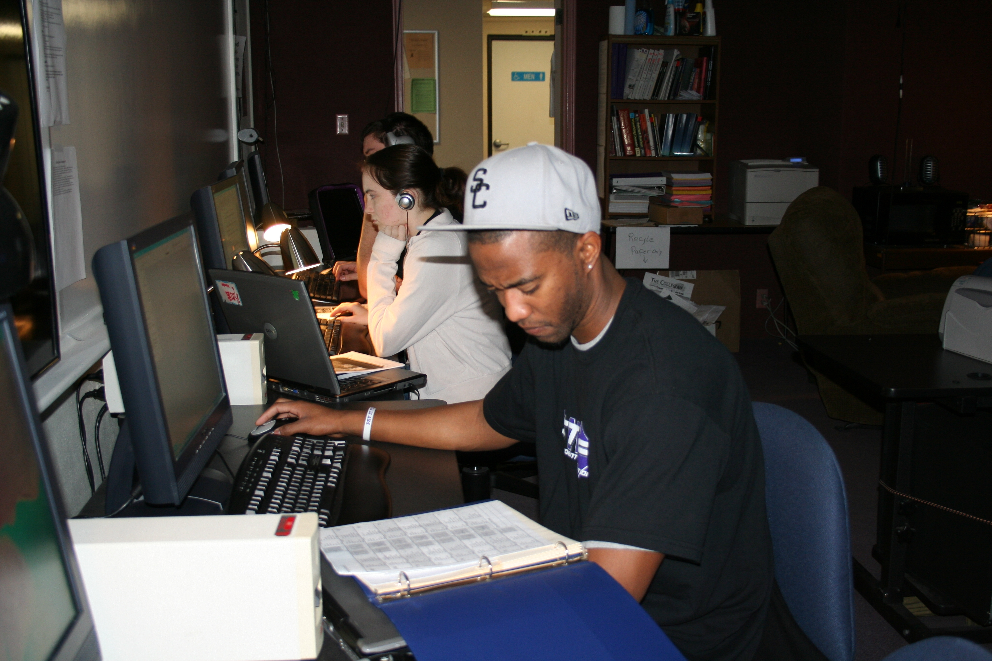
General Communication

Communication Internship Finder:
The country faces enormous challenges. PublicAgenda.org is designed to provide citizens and leaders with the tools they need to tackle them. You'll be able to get the critical facts, consider the choices and current public opinion, and learn new ways to work together on fundamental problems facing the country.
http://www.publicagenda.org/

Genocide/Intervention:
Genocide Intervention Network (GI-NET) is changing the way the United States and the international community responds to the world's worst crime by empowering individuals and communities with the tools to prevent and stop genocide. Internships are available for undergraduate and graduate students or recent graduates who are available for at least 20 to 40 hours per week for at least 2-3 months.
http://www.genocideintervention.net/

