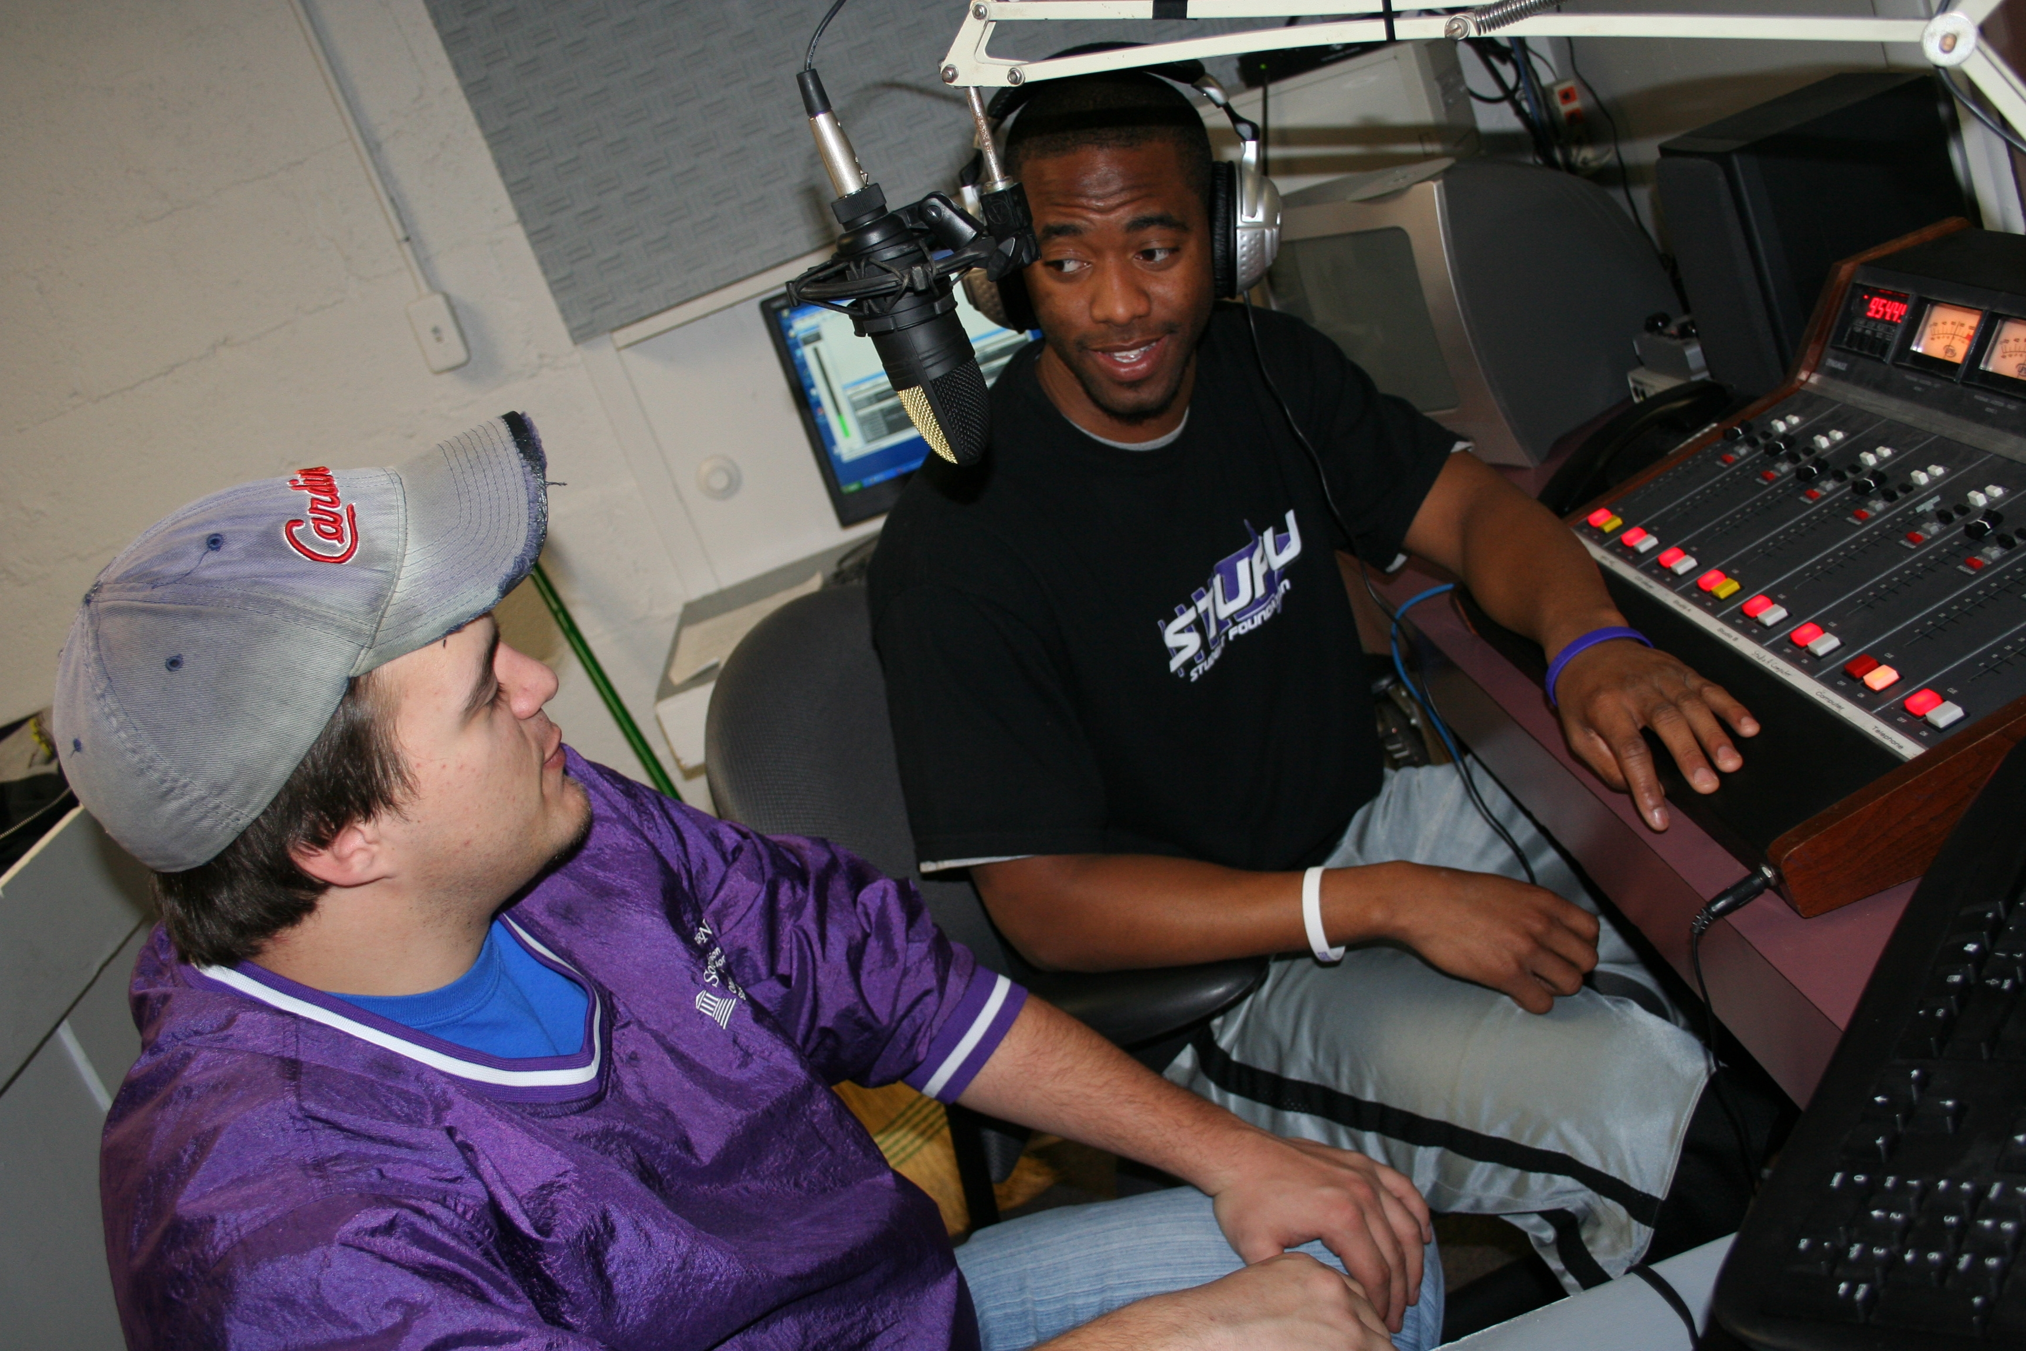

Radio and Television Production and Performance

NHL Hockey:
The BostonBruins.com Internship is a position that works with the Bruins Content Manager at BostonBruins.com, within the Bruins Communications Department. Interns will gain experience working on the Public Relations side of sports writing.
http://hockeyjobs.nhl.com/teamwork/jobs/jobs.cfm/Internships?supcat=222

Wolf Trap:
The Communications and Marketing Department is responsible for publicizing and marketing all of Wolf Trap's programs and for ensuring a strong and consistent corporate image throughout all materials and promotional pieces relating to Wolf Trap.
http://www.wolftrap.org/Education/Internships_for_College_Students/Internships/Communications_Marketing.aspx

KSDK:
We highly encourage each intern to make a total commitment to the experience and stay through the conclusion of that semester's program. Hours vary. In the summer we hope interns can spend 30 hours a week here. During the school year, we anticipate 20-25. We are also extremely flexible when it comes to a student's schedule. We work with each students to make sure that student is having a quality experience, getting school work done and spending enough time here to understand the business.
Each intern has tasks in a variety of areas on all of our platforms. The areas include the assignment desk, the sports office, the special projects area of the newsroom, our websites, the community relations office, the "Show Me St. Louis" team and a host of other options. Students apply to the program only, not a specific area.
http://www.ksdk.com/company/jobs/interns.aspx

For consideration, please forward resume and letter of interest to: Human Resources Department, WFLD & WPWR FOX Television Stations, Inc., 205 N Michigan Ave, Chicago, IL 60601 Fax: 312-565-3066 email: WFLD-HR@foxtv.com. Web site: www.myfoxchicago.com NO PHONE CALLS PLEASE. EOE/M/F/D/V


NEWS PRODUCER

KAKE-TV has an immediate opening for a News Producer.

We are looking for candidates who combine great news judgment,
exceptional writing skills, and the ability to produce compelling, fast-paced newscasts.

Candidates must have experience producing daily newscasts. The ability to work under deadline pressure and to adjust to last minute changes is critical.

We provide news and information for customers when they want it. Candidates must have experience producing content for the internet and other platforms.

If you’re a team player, come join our Emmy Award winning news team.

Send resume and DVD to:

Dave Grant
News Director
KAKE-TV
1500 N. West
Wichita, KS 67203
No telephone calls
KAKE-TV is an equal opportunity employer. Pre-employment drug screen is required.

2-1-10

