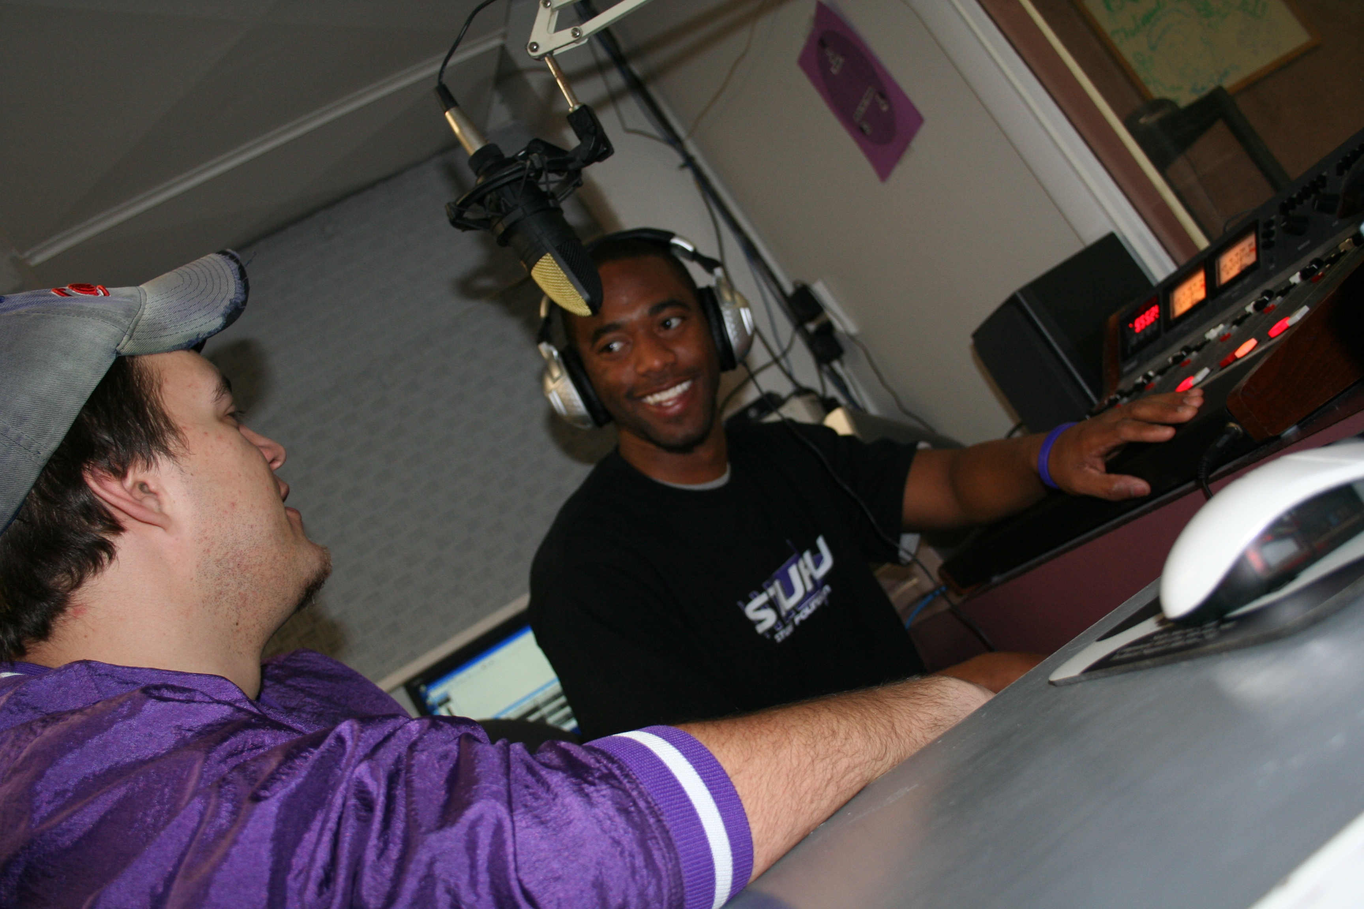

Radio and Television Production and Performance

Entertainment Career Finder:
Entertainment jobs and internships listings at Studios, Networks, Production
Companies, Record Companies, TV and Radio Stations, VFX, Animation, Broadcasting
http://www.entertainmentcareers.net/

Fox News Jobs:
WFLD/ WPWR · Chicago
- Manager of Video Content:
The successful candidate will lead team of news technicians, ensuring industry's best practices for shooting, editing and transmitting video for on-air and all digital platforms. The candidate will be a news photographer/editor with a minimum of seven(7 ) years' major market or network experience. Bachelor's degree in journalism or related field preferred. Must be proficient in cutting-edge techniques for digital news gathering, video and audio field editing and transmission. Non-linear editing skills and ability to meet deadlines required. Must be devoted to the highest standards of journalism and guard technical quality at all times. Must reinforce safety practices. Must have experience with the latest lighting techniques and possess extensive experience operating microwave and satellite trucks for remotes. Will supervise media librarian to establish newsroom systems and protocols for delivery, organization and storage of media. Trains and coaches photographer/editors on techniques to improve efficiency and quality of work. Computer skills needed, including hands-on experience with latest technology for transmitting live reporter standups and video by internet. Position requires diagnostic skills to assess and solve technical problems on deadline. Scheduling and budget responsibilities, including tracking of helicopter hours and staff fees/overtime. Must also work closely with engineering department, news coverage manager and reporters. Familiarity with Panasonic P2 technology and the Chicago area, a plus. Other duties as deemed appropriate and as assigned. Moderate stair climbing, standing, sitting at workstation, and bending. Other duties as deemed appropriate and as assigned.
- Web Sales Manager:
Candidate will support Sales department and play the lead role in the growth of Fox Television Stations web sites and sales. Position reports to the Vice President of Sales-General Sales Manager and will be responsible for the station sales budgeting, prospecting, presentation creation, pitching, negotiating, closing and managing online revenue. Position required to interact and lead local and national account executives in the effective positioning and selling of station web site. Candidate will be strongly focused on developing new revenue through the sale of inventory on station's web sites but will also work with existing accounts. This candidate will be charged with developing creative web only and multi-platform campaigns utilizing WFLD, WPWR & myfoxchicago.com assets. Other duties as deemed appropriate and as assigned. Must have three to five years of online sales experience with proven sales track record. Additional ad sales experience in offline media preferred. Must possess a working knowledge of all online metrics, technologies and research tools used in marketplace. Must have strong relationships with key ad agency personnel. Experience in direct sales and interactive agencies preferred. Comprehensive knowledge of the internet and online advertising. Effective verbal and written communication skills is mandatory for this position. Strong time management and good organizational skills required. Demonstrated presentation skills a must. Demonstrated leadership qualities and experience preferred.
- Anchor/Reporter:
The successful candidate will be required to anchor daily or special event newscasts on-air or web. The candidate will be responsible for fill-in anchoring, as needed and reporting duties, as assigned. Candidate will write and read stories for newscasts and station website, assist proofreading stories and occasional re-writes. Voice-over written material, write and produce feature/special packages, perform basic editing of video on desktop, make public appearances identified by station management and perform promotional responsibilities. Duties include originating creative content for myfoxchicago.com with goal of driving loyalty to both website and newscasts. Candidate must have major-market or network experience reporting and anchoring newscasts. College degree in journalism preferred. Strong verbal and written communications skills required. All other duties as assigned and deemed appropriate. Physical Requirements: Works with computers for the majority of shift. Sitting, walking, standing, reaching, leaning, bending, stooping, telephone, fax use, light bending and lifting up to 20 lbs.
- Programming Manager:
Candidate will maintain contract files and administration, calculate film amortization for month end and forecasting. Will monitor usage and perform scheduling within contract terms and be responsible for FCC children's reporting and for Station's public file. Develops year round budget reports. Oversees and maintains programming grids. The successful candidate will be the liaison between the station and legal as it relates to programming. Will oversee all syndex and cable carriage issues and compliance in coordination with corporate legal. Perform general clerical functions as well as, other duties as deemed appropriate and assigned. Candidate must have 3-5 years of program accounting and administration experience, and a degree in communications, accounting or finance preferred. Must be well organized, able to examine, observe, and handle details, and able to work in a fast paced environment. Must have knowledge of the Nielson and Encoda system. Knowledge of Enterprise Film System, high level of computer skills (MS Excel and MS Word a must), and being able to work at various tempos, independently, and flexible hours. Position also requires moderate sitting at workstation, standing, walking, stair climbing, telephone and fax use, and light bending.
- Web Producer:
Candidate works on deadline to produce news stories for all digital and on-air platforms. Candidate will be required to evaluate multiple sources of information, graphics and pictures to create stories that are compelling and relevant to audience. May be required to assist with newscast producing, as assigned. Working in a non-linear, tapeless environment, the candidate must select and edit video on desktop to complement news copy. Writes stories and edits newscast copy and wire copy stories to adapt them for a Web audience. Produces exclusive content to create unique Web traffic, including: text, galleries, live chats, lists, maps, raw video and other tasks as assigned. Must have excellent news judgment and knowledge of Chicago area. The successful candidate will be responsible for accuracy of copy, choosing video and sound, creating graphics, as well as gathering all relevant facts for news stories. Monitors community and blog forums. Updates station's Facebook, Twitter and other social media pages. All other duties as assigned and deemed appropriate. Candidate must have 2-3 years television web and news writing experience and internet experience and college degree in journalism or equivalent. Experience with internet research, computer knowledge, INews and Avid preferred. Strong newscast producing skills, a plus. Knowledge of Search Engine Optimization techniques strongly preferred. Must be creative, concise, attentive to detail, be able to handle deadline pressure, take direction from producers and adapt quickly to emerging Web technologies and social media. Must have knowledge of HTML, Content Management Systems and A.P. Style. Ability to stay current on Web standards and best practices. Experience with multiple Content Management Systems. Proven ability to generate audience participation through social media preferred. Ability to share knowledge with others preferred. Knowledge of Flash a plus. Ability to design Web pages using CSS a plus.

http://www.myfoxchicago.com/subindex/job_shop

