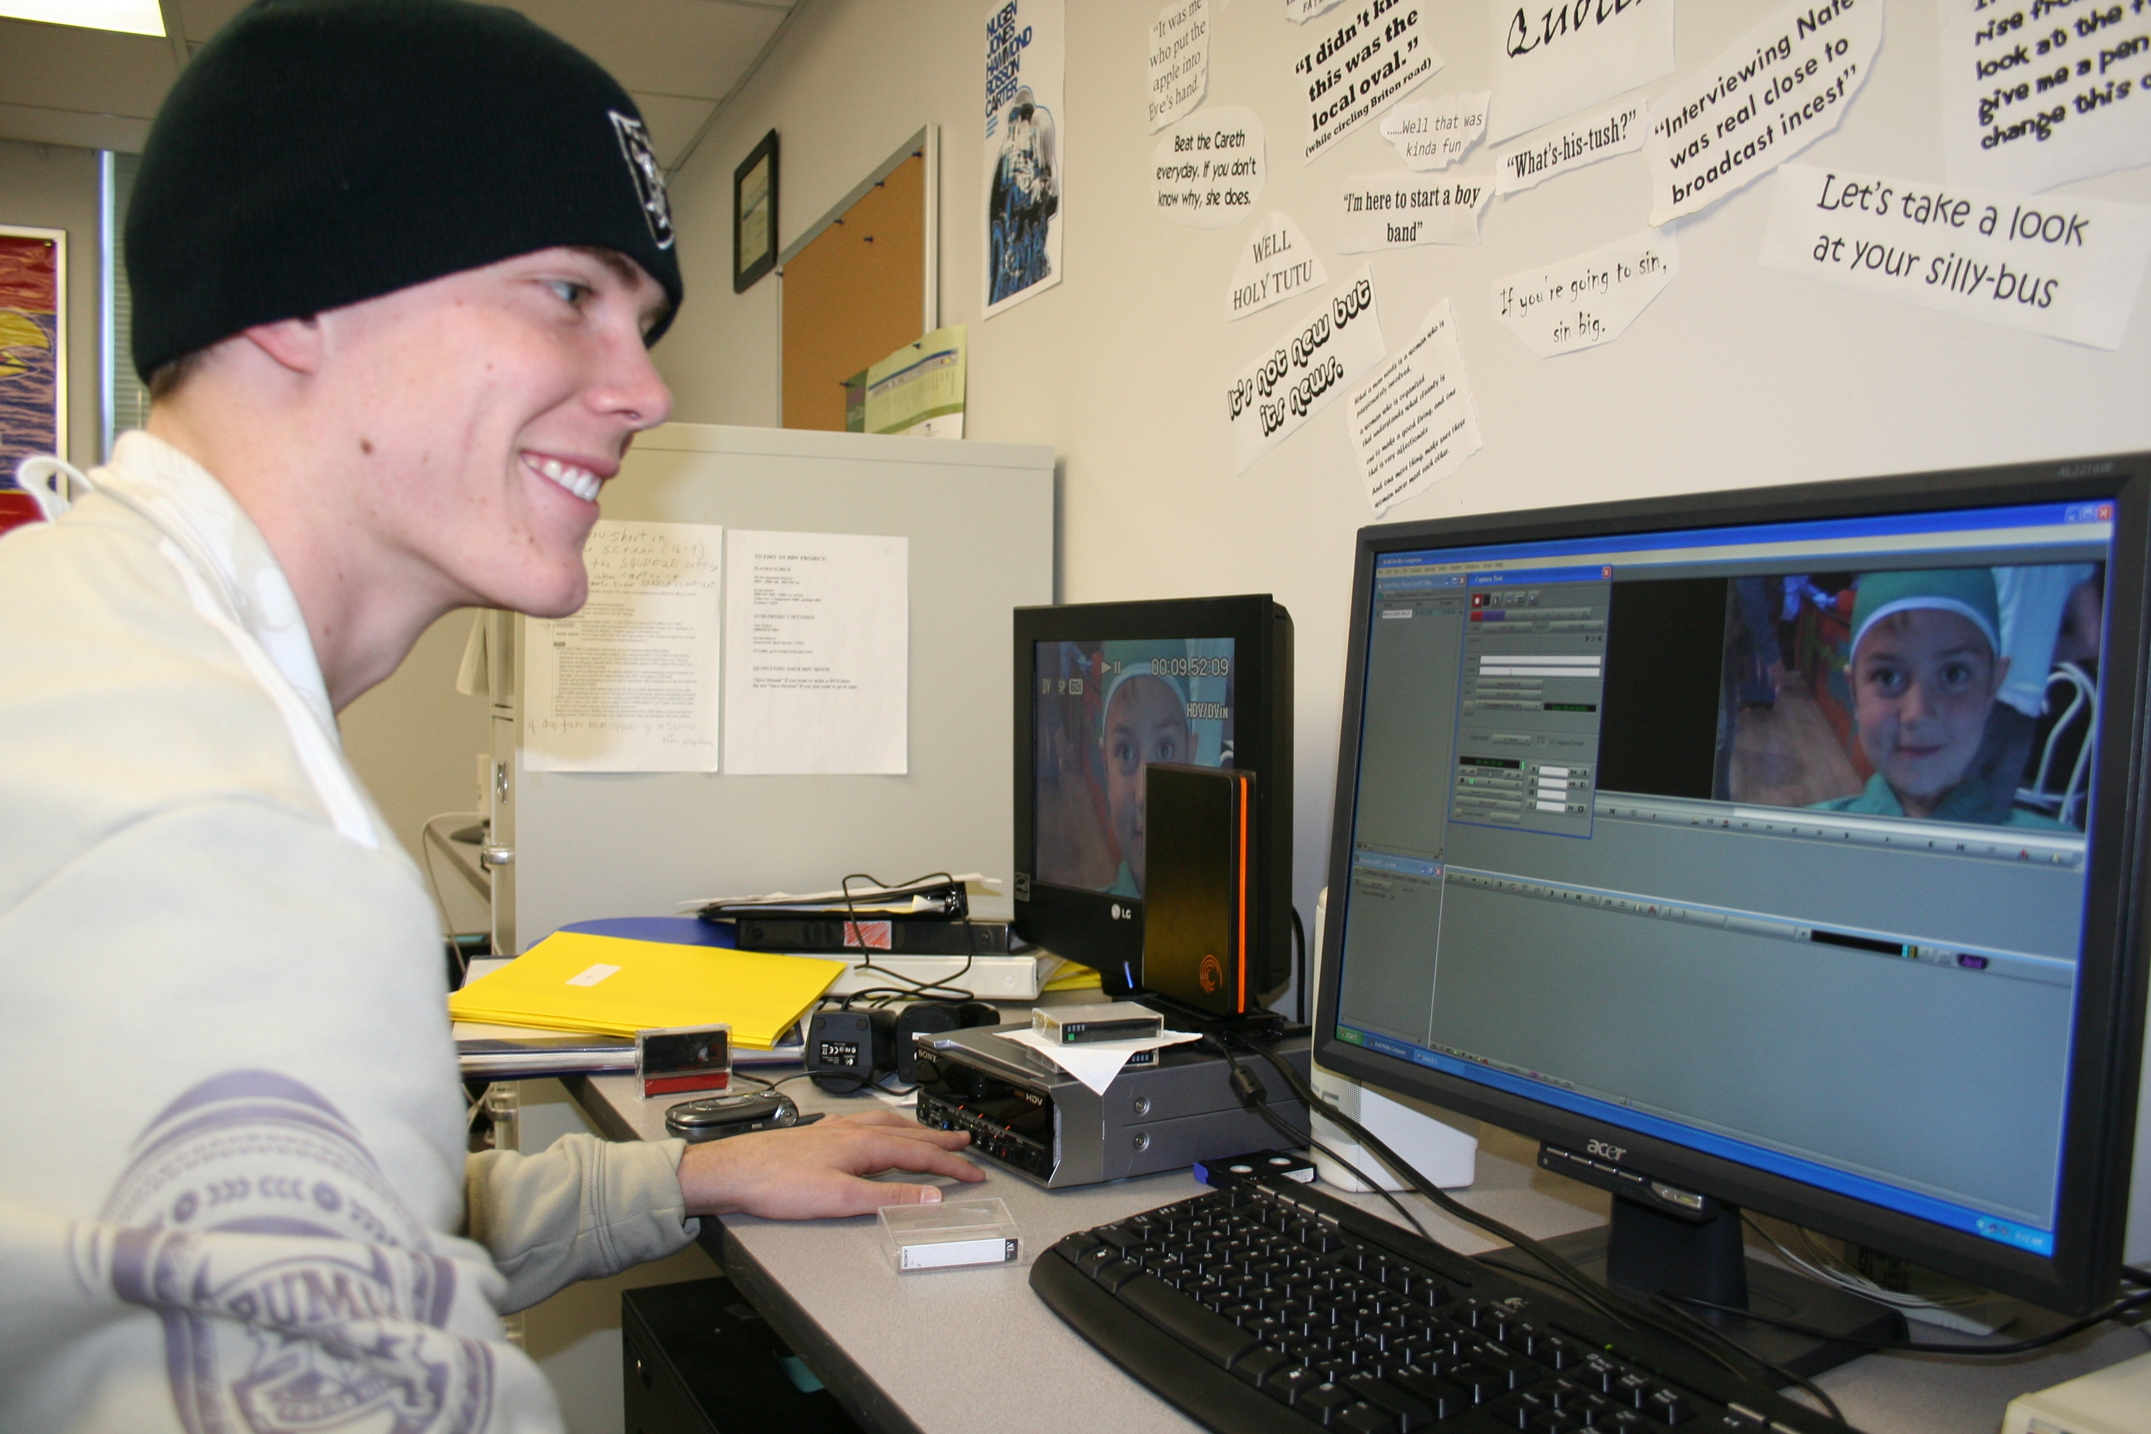

All Emphasis

University of Dreams:
World’s leading internship program provider.
http://www.summerinternships.com/

PBS:
PBS offers employment opportunities in a variety of disciplines including communications, engineering, accounting, information technology, creative services, development, programming, interactive services and many other areas.
http://www.pbs.org/aboutpbs/aboutpbs_jobs.html

American Advertising:
http://www.aaf.org/default.asp?id=148

Boston College Internships:
Boston College offers many internship opportunities in the communication fields.
http://www.bc.edu/offices/careers/internships/howto/communications.html

Internship-Finder:
Provides students with a list of internship opportunities in the communication fields with several locations.
http://www.rsinternships.com/applications/job_sectors.php3?sector=COMMUNICATIONS

Federal Communication Commission:
The Federal Communications Commission offers legal and non-legal internship opportunities throughout the year. Internships provide opportunities for interested students to increase their knowledge of the issues and technologies that are shaping the telecommunications market, while at the same time providing invaluable support to the Commission. The FCC is always looking for bright and motivated students who want to participate in one of our many programs and gain valuable experience with a federal agency.
http://www.fcc.gov/internships/

Arizona-Mexico Commission:
Gain valuable work experience, expand your resume, network with Arizona public and private community leaders, produce real-world work samples and earn recommendation letters for your portfolio.
http://azmc.org/story/?ID=250

Cisco:
Join Cisco and immediately contribute to how the company innovates, sells, and supports the solutions that are shaping the future: a future of experiences delivered over the Internet. Cisco offers a unique set of programs and opportunities for recent college and university graduates, as well as students looking to gain valuable, real-world experience as an intern or co-op while attending school. To begin, you may read more about specific programs listed below, or you may search all opportunities. You may also want to take advantage of upcoming Live Virtual Information Sessions. The virtual information sessions are designed to be question and answer sessions generated from viewing one of our Previously Recorded Virtual Information Sessions. These information sessions are held by current Cisco employees in the business. You will hear first hand from them what their job is like and how they make a difference at Cisco.
http://www.cisco.com/web/about/ac40/univ/us_canada/internships_uc/index.html

Women in communications:
Savvy Ladies A non-profit dedicated to empowering women through financial education Internship Job Description We are seeking a motivated individual who thrives in a challenging environment and is committed to helping Savvy Ladies fulfill its mission to empower women through financial education. This individual must be ethical, hardworking, good at organizing and coordinating events and have a passion for helping women achieve financial independence.
http://www.nywici.org/students/internships-available/event-planning

Hudson Institute:
Hudson Institute is one of the oldest and most respected think tanks in the world. Founded in 1961 by Herman Kahn and headquartered in Washington D.C. the Institute offers internships in our office in Washington, D.C. to undergraduates, graduates, and postgraduate students. Hudson has garnered local, national, and international acclaim with its hands-on research and offers a unique opportunity for its interns to work with Hudson researchers in policy areas such as Campaign Reform, Economic and Employment Policy, Middle East Studies, Philanthropy and Civic Renewal, National Security Studies, and Science in Public Policy.
http://www.multiculturaladvantage.com/opportunity/internships/detail/rolling/Hudson-Institute-Marketing-Communications-Internships.asp

National Communication Association:
The National Communication Association provides many students and graduate students the opportunity to find careers in their specific communication field.
http://www.natcom.org/index.asp?sid=14

Volunteers of America:
Volunteers of America provide a list of career opportunities in the new media, professional communications, and general communication areas.
http://www.voa.org/Careers/National_Office_Careers.aspx

