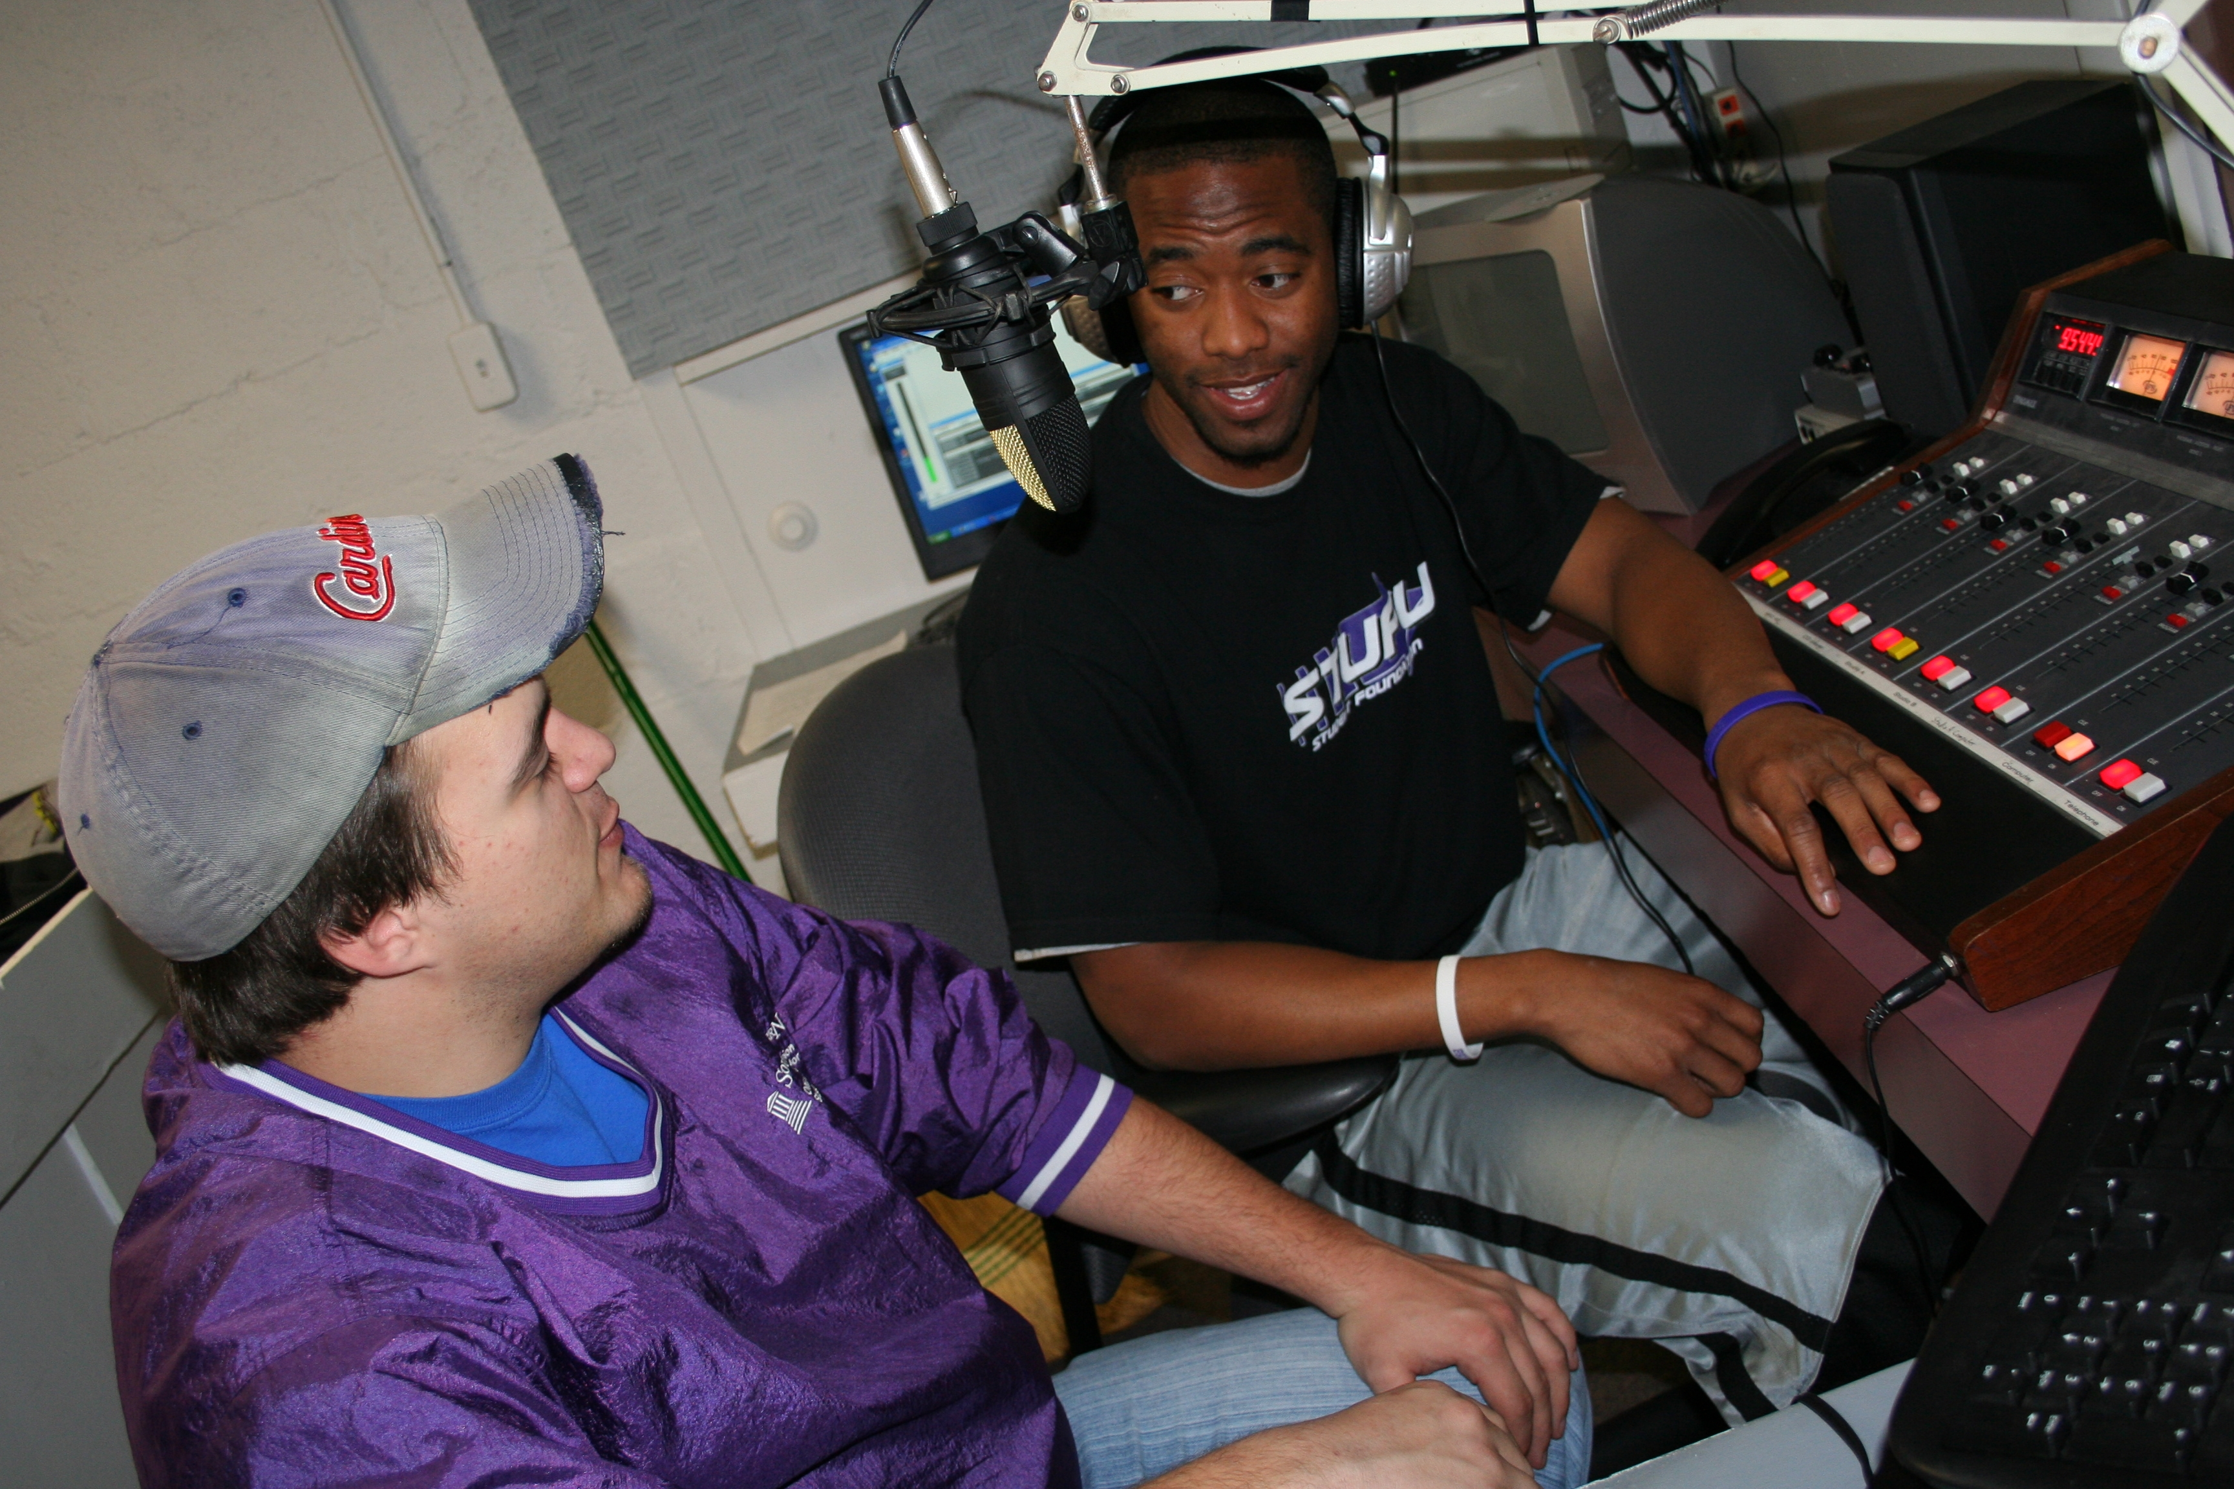

Radio and Television Production and Performance

KSDK:
We highly encourage each intern to make a total commitment to the experience and stay through the conclusion of that semester's program. Hours vary. In the summer we hope interns can spend 30 hours a week here. During the school year, we anticipate 20-25. We are also extremely flexible when it comes to a student's schedule. We work with each students to make sure that student is having a quality experience, getting school work done and spending enough time here to understand the business.
Each intern has tasks in a variety of areas on all of our platforms. The areas include the assignment desk, the sports office, the special projects area of the newsroom, our websites, the community relations office, the "Show Me St. Louis" team and a host of other options. Students apply to the program only, not a specific area.
http://www.ksdk.com/company/jobs/interns.aspx

KAKE-TV – Wichita, Kansas:
NEWS PRODUCER
We are looking for candidates who combine great news judgment,
exceptional writing skills, and the ability to produce compelling, fast-paced newscasts. Candidates must have experience producing daily newscasts. The ability to work under deadline pressure and to adjust to last minute changes is critical. If you’re a team player, come join our Emmy Award winning news team.
http://www.kake.com/station/jobs/83260177.html

Master Control Operator KAKE-TV: Operations has an opening for a Full-Time Master Control Operator. This position will primarily be a 3rd shift work schedule, including weekends. The position will be responsible for Master Control board/automation operation and transmitter monitoring for three full-power digital stations, four translators and one cable outlet. Will switch in commercials, promos, and other live and taped elements into programs during a shift. Will tune in satellite and microwave receivers. Will also cover some shifts as audio board operator and floor crew for Operations, depending on shift. KAKE-TV is a 24/7 broadcast station with Master Control shifts covering all hours.
http://www.kake.com/station/jobs/83889817.html

Video Editor KAKE-TV: has an immediate opening for a Full-Time Video Editor. The position is responsible for editing videotape to be used in the station’s newscasts, recording satellite feeds, and being in charge of the station’s video archive system. We are looking for someone who is creative and can function effectively under deadline pressure.
http://www.kake.com/station/jobs/80927757.html

KWCH:

Bi-Lingual Television Account Executive: Sunflower Broadcasting, Inc. is currently accepting applications for a full-time Television Account Executive for television sales. Must have a background in advertising, broadcasting sales, or sales with related experience. Must have computer skills, including Excel, Word, & Power Point; good communication skills, creative skills, some knowledge of commercial production. Must have some experience at generating non-traditional revenue, including the internet, and new business development. Must be well organized, self motivated, have a strong desire to succeed, and be able to speak both English and Spanish well.
http://kwch.images.worldnow.com/images/incoming/pdfs/Jobs.pdf

TELEVISION/WEB SALES ACCOUNT EXECUTIVE – all locations plus Great Bend:
Sunflower Broadcasting, Inc., consisting of KWCH-TV, KSCW-TV, and satellite stations KBSD-TV, KBSH-TV, KBSL-TV, is currently accepting applications for a full-time Television/WebSales Account Executive for television and web sales. Must have a background in advertising, broadcasting sales, or sales with related experience. Must have computer skills, including Excel, Word, & Power Point; good communication skills, creative skills, some knowledge of commercial production. Must have some experience at generating non-traditional revenue, including the internet, and new business development.
http://kwch.images.worldnow.com/images/incoming/pdfs/Jobs.pdf

Entry Level Television/Web Sales Account Executive: Sunflower Broadcasting, Inc., consisting of KWCH-TV, KSCW-TV, and satellite stations KBSD-TV, KBSH-TV, KBSL-TV, is currently accepting applications for an entry lever full-time Television/Web Sales Account Executive for television and web sales. Must have computer skills, including Excel, Word, & Power Point; good communication skills and creative skills. Must be well organized, self motivated, and have a strong desire to succeed.
http://kwch.images.worldnow.com/images/incoming/pdfs/Jobs.pdf

Web Coordinator: We need a dynamic and organized individual to fill our opening for Web Coordinator. The Web Coordinator will be responsible for maintaining the FetchToto Web site. The right candidate will be tasked to gather information from clients and design and code client pages. Candidates must demonstrate the ability to manage multiple projects simultaneously and have the ability to multi-task in a fast-paced environment.
http://kwch.images.worldnow.com/images/incoming/pdfs/Jobs.pdf

KSN:

10pm Newscast Producer KSNW-TV (KSN News 3): Produce clear, concise and compelling newscast for flagship 10pm show. This is a graphics-intensive broadcast; must be creative and work with graphic artist and show director on pre-produced elements. Ensure that all standards of fairness, accuracy and relevancy are met. Responsible for "boothing" show, including timing and reacting to breaking news. Proficiency in newsroom computer systems. Ability to handle multiple tasks, write clear and concise copy, competency in spelling, grammar and punctuation. Maintain a positive work environment through active team participation.
http://www.ksn.com/content/about/jobs/story/Jan-29-2010-10pm-Newscast-Producer/N8nf6dH_5U26gwinj7LDCw.cspx

Bureau Reporter KSNW-TV (KSN News 3): Gather information for newscast presentation with accurate information and of interest to our viewers. Have the ability to anchor and edit together "cutins" that are inserted in the statewide newscast. Be self-sufficient and take ownership of a bureau, covering a large geographic area. Willingness to jump on breaking news at a moment’s notice, any time of the day. Conduct yourselfe in a courteous and professional manner. Interact with all facets of the community to gather information and cultivate news sources. Represent the station at community events in a professional manner. Must have excellent reading, writing, spelling, grammar, organizational and interpersonal skills. Proficiency in newsroom computer systems. Ability to handle multiple tasks and moderate to high stress and deadline pressure.
http://www.ksn.com/content/about/jobs/story/Jan-14-2010-KSN-Bureau-Reporter/ZEYL0NEcwEqHlwCtOW09EQ.cspx

KSNW TV in Wichita: has an opening for a Weekend Morning Meteorologist. This is a great opportunity for someone looking for lots of severe weather coverage, and plenty of fill-in work on other shifts. The KSN WeatherLab fosters an enthusiastic and encouraging environment, and teamwork and dedication make it a great place to work. We are looking for someone who wants to help us continue to grow our weather product across all platforms. Duties will include preparing and delivering weathercasts, severe weather coverage, graphics and other products on TV, our cable station, mobile, the Internet, radio and more; assisting with forecast and graphic preparation; and other duties to be assigned.
http://www.ksn.com/content/about/jobs/story/Jan-8-2010-Newscast-Meteorologist/kHyTZBrTQUmp8kxvP7HjSQ.cspx

KSNW-TV: is looking for a graphic artist to assemble graphics and build animations for our weeknight newscasts (5, 6, 10pm). If you have an eye for cutting edge television news graphics, we want to talk to you! Additionally, you’ll have the opportunity to layout print pieces, plus build graphics and animations for our commercial production and sales teams. Candidate will assist with studio teleprompter operator during some evening newscasts.
http://www.ksn.com/content/about/jobs/story/Jan-7-2010-Evening-Graphic-Artist/8yPxvd7xkEGlxsxBmtOEUA.cspx

Interactive Account Executive: Looking for an opportunity where you can set your own income? Looking to work with a great group of people who are client focused and results driven? Are you a positive person who looks for the opportunity in every challenge and situation? If you are, then we want to talk. Generate local revenue for KSNW by selling problem-solving ideas using interactive marketing solutions, interactive sales packages and interactive sales promotions. Prospect and develop new advertising clients for KSNW. Develop and maintain positive working relationships with advertisers and agencies by partnering with the customers, making personal sales calls, providing quality customer service and being pro-active in dispute resolution.
http://www.ksn.com/content/about/jobs/story/Jan-14-2010-Interactive-Account-Executive/a8j_TEvdZUyHq0nv2rCrVQ.cspx

Sales Account Executive: Looking for an opportunity where you can set your own income? Looking to work with a great group of people who are client focused and results driven? Are you a positive person who looks for the opportunity in every challenge and situation? If you are, then we want to talk. Generate local revenue for KSNW by selling problem-solving ideas using all available advertising tools, including commercial spot time, interactive marketing solutions, sales packages and sales promotions. Prospect and develop new advertising clients for KSNW. Develop and maintain positive working relationships with advertisers and agencies by partnering with the customers, making personal sales calls, providing quality customer service and being pro-active in dispute resolution.
http://www.ksn.com/content/about/jobs/story/Jan-14-2010-KSNW-Account-Executive/Ek6G1PdqE0Syus9j0mA7OA.cspx

NHL Hockey:
The BostonBruins.com Internship is a position that works with the Bruins Content Manager at BostonBruins.com, within the Bruins Communications Department. Interns will gain experience working on the Public Relations side of sports writing.
http://hockeyjobs.nhl.com/teamwork/jobs/jobs.cfm/Internships?supcat=222

Wolf Trap:
The Communications and Marketing Department is responsible for publicizing and marketing all of Wolf Trap's programs and for ensuring a strong and consistent corporate image throughout all materials and promotional pieces relating to Wolf Trap.
http://www.wolftrap.org/Education/Internships_for_College_Students/Internships/Communications_Marketing.aspx

NCA Career Center:
Find the position that's right for you using the NCA Career Center. Access the newest jobs available to professionals seeking employment.
http://www.jobtarget.com/c/search_results.cfm?site_id=560

DCInternNet:
DCinternNet.com was recently started by faculty and students in communication to help students find internship opportunities in Washington D.C. Excellent summer internship opportunities are currently being posted, so interested students should go to the web site to sign up for information.
http://www.dcinternnet.com/

