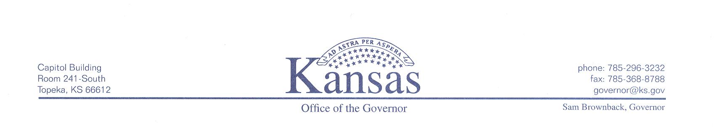
Office of Governor Sam Brownback
Internship Program

Governor Sam Brownback, Lt. Governor Jeff Colyer, MD & the Cabinet Secretaries are pleased to offer Kansas college students the opportunity to participate in an outstanding public service internship program
Categories for Internships Opportunities include:
- Appointments
- Communications
- Constituent Services
- Lt. Governor’s Office
- Legal
- Policy
- Cabinet Level Agencies
- Governor’s Commissions
Internships are available for:
- Undergraduate students
- Graduate students
- Law students
Application Deadline for the Summer Internship Program is April 15th

For more information, and to submit an application,
please visit the Serving Kansans section at http://governor.ks.gov

