Go to http://selfservice.sckans.edu

Log in with your ID (it would be your student ID# or employee ID#) and password
If you do not have a Self-Service account, click on the request account link and follow the process
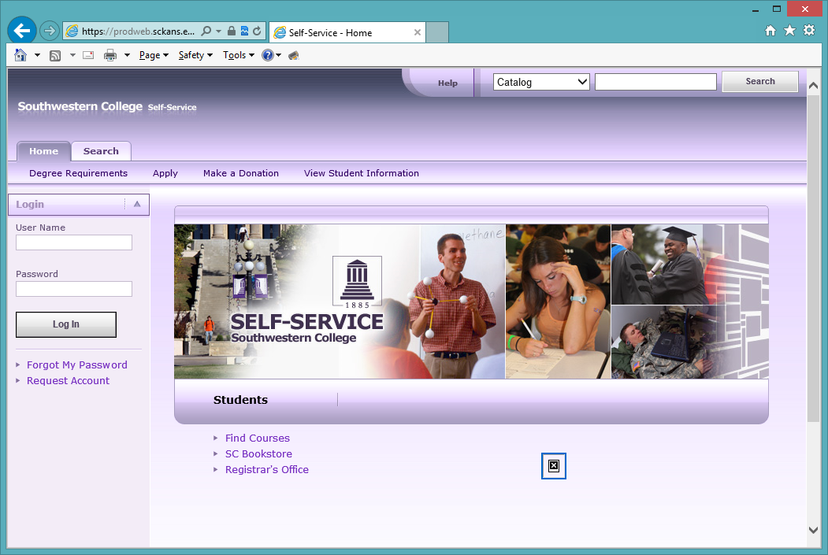

Click on My Profile
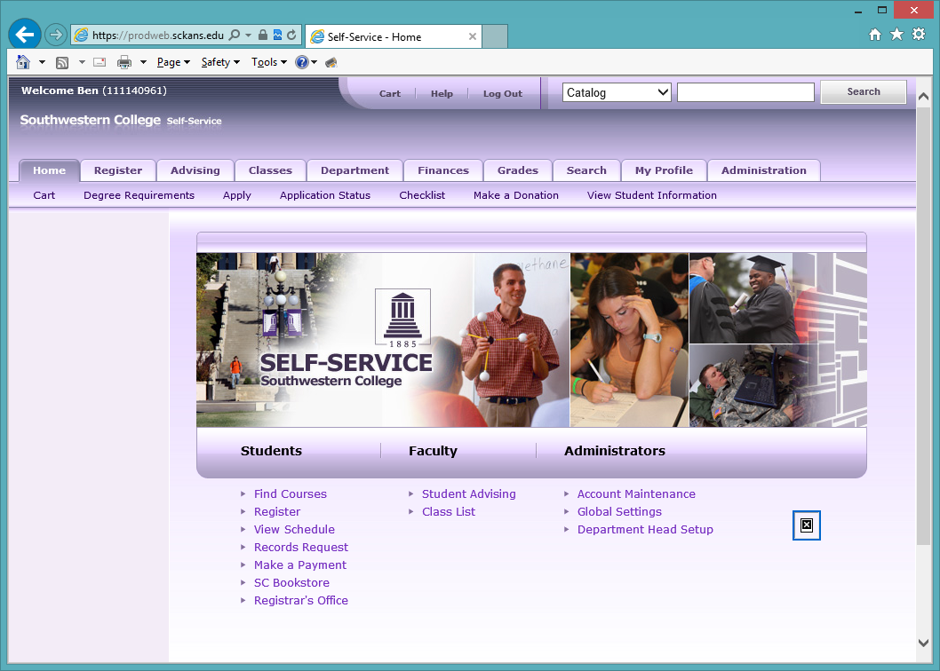

Click on Phone Number
You can choose to Edit, Delete Make Primary. You can only delete if you have more than one phone number in the system.
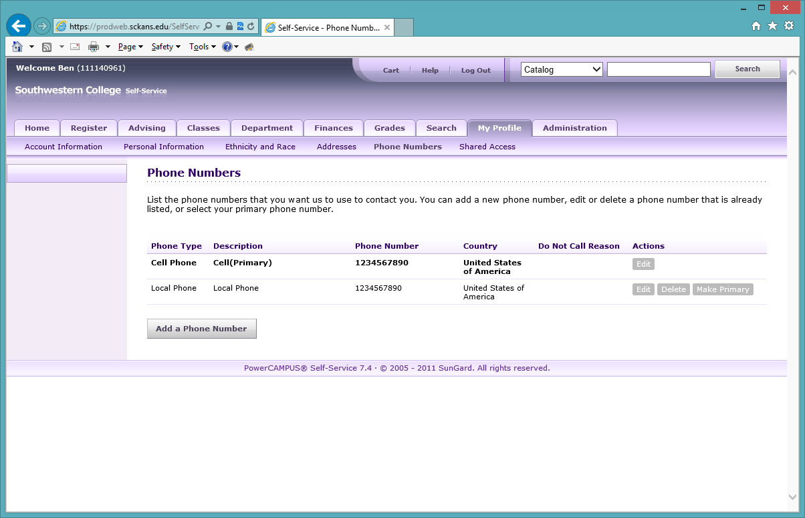

We would like to have at least a cell phone or your local (home) phone number. Please leave the Do Not Call Reason blank.
