Regroup Instructions - Joining Southwestern Network and SC Emergency
- Please go to https://sckans.regroup.com/signup to start the sign up process.
- The link will bring you to the following screen:
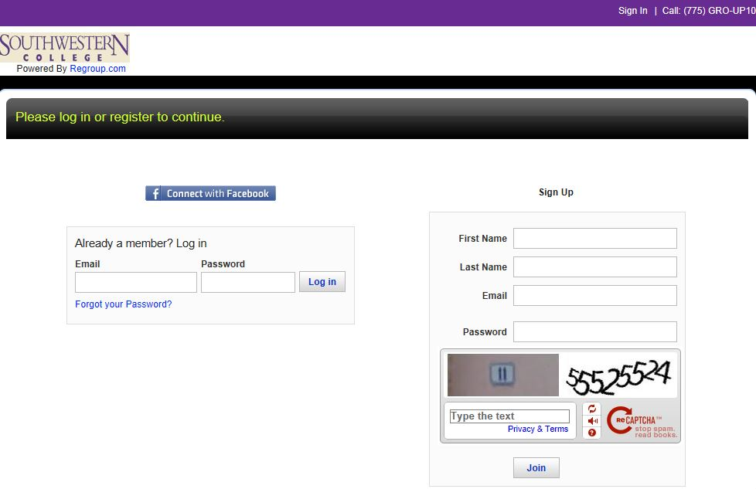
- Using the sign up box on the right please enter first name, last name, email, and the password you want to use for the account. The email address will be your username and will be the primary email address to send emergency messages to. Enter the code at the bottom for security purposes to press join.
- This will take you to the following screen:
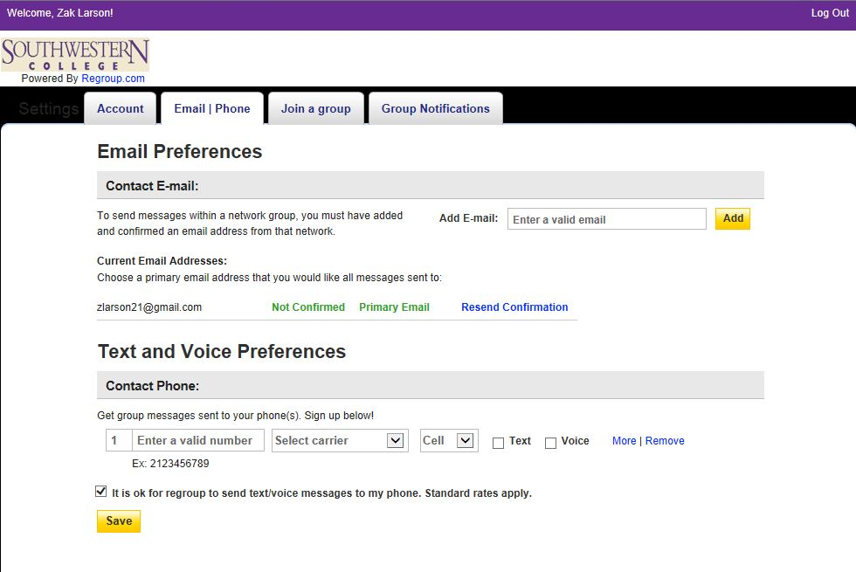

- This will bring you to the email | phone tab. Here you can add additional email addresses for notifications, change your primary email address, and add phone numbers to your profile. Please enter your 10 digit phone number and select the phone type. Please check the way you want to receive notification on your phone by selecting Text and/or voice buttons. Remember to SAVE your changes.
- Now it is time to select the SC Emergency group. Select the Join a group tab and it will bring you to the following screen:
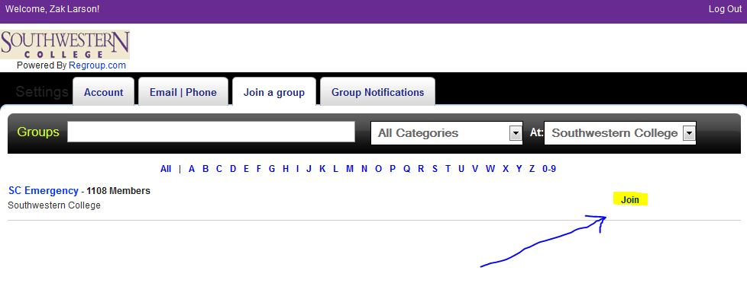
- Click join on the right hand side and this will put you in the SC Emergency group for notification of emergency on campus at Southwestern College.
- At this time you can log out of the system by clicking log out in the top right corner of the screen.
- You will be sent an email from do-not-reply@regroup.com to verify your email address with regroup. Click the link in the email and it will confirm your email identity.
- That concludes your enrollment process.

If you have any further questions please contact the SC Helpdesk:
sc.helpdesk@sckans.edu
620.229.6444

