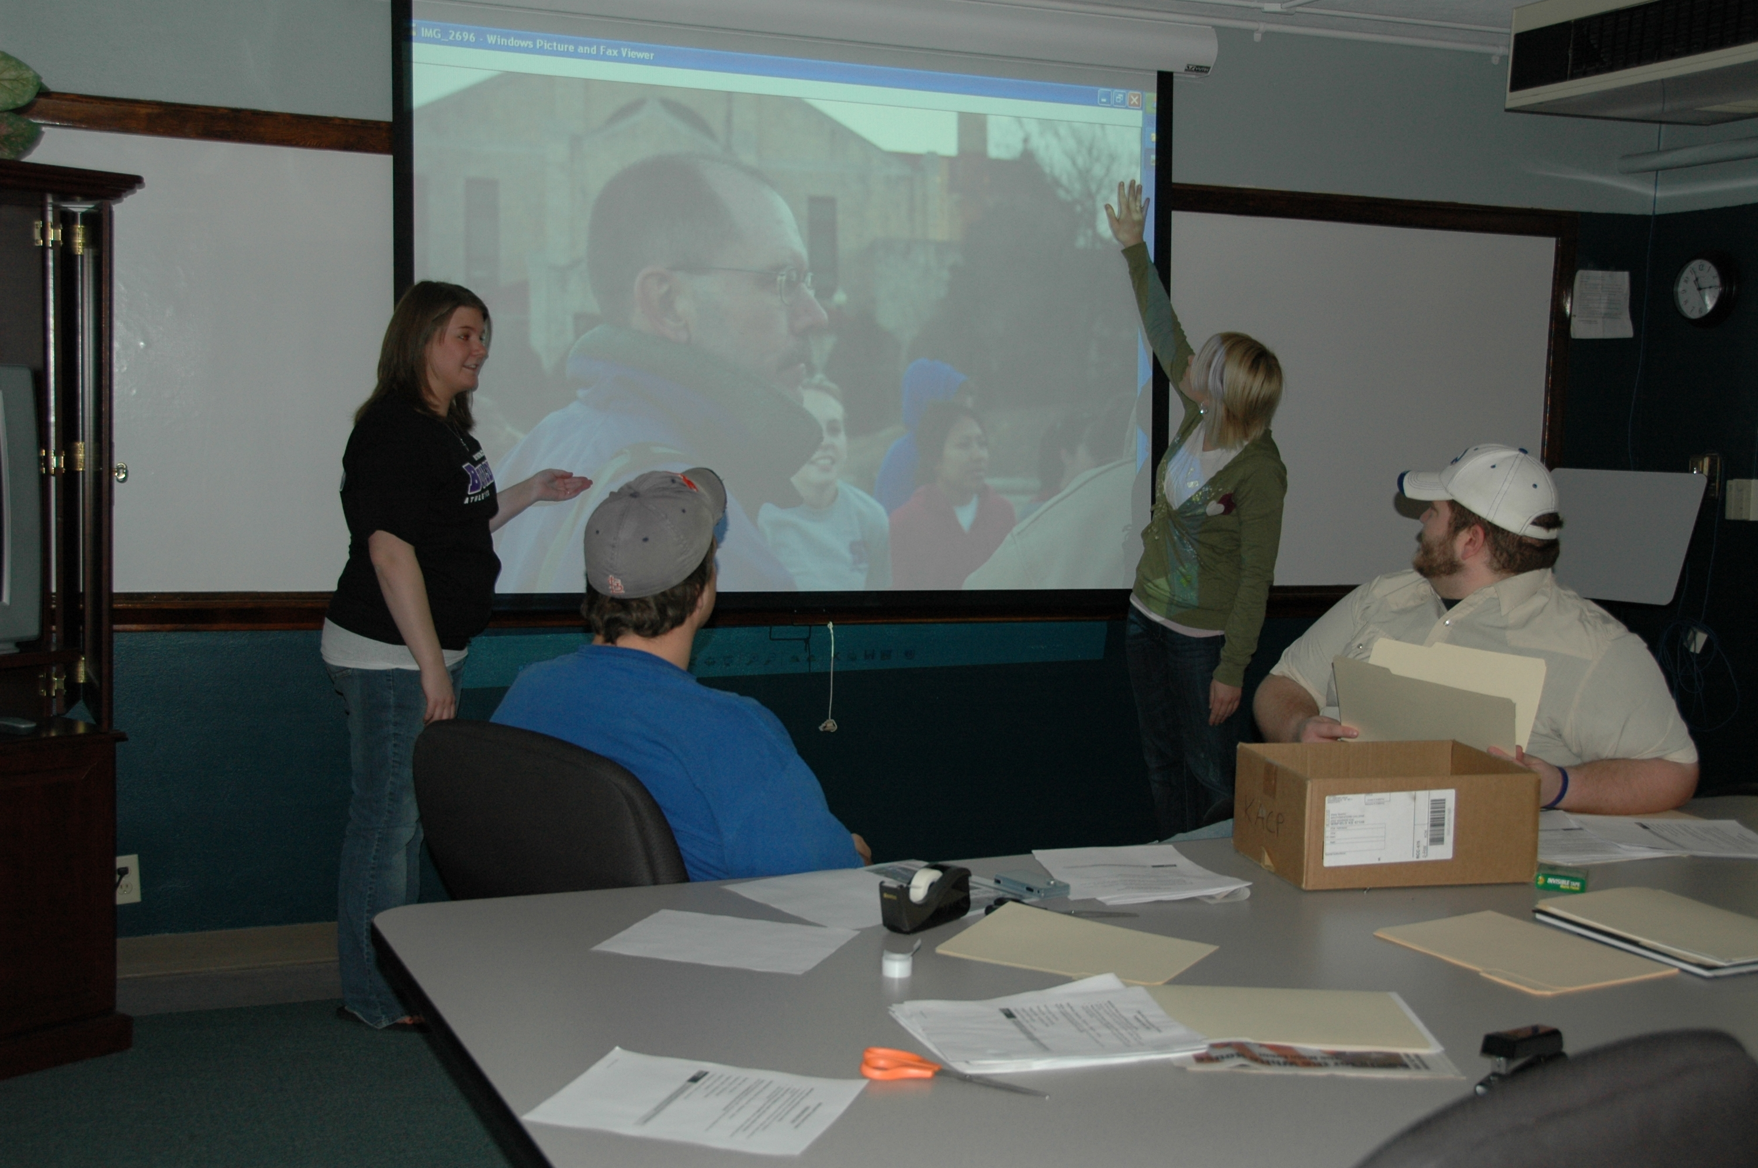
Convergent Journalism

KONZ FM
KONZ FM, Manhattan, KS’s community radio station, is looking for an AmeriCorps*VISTA to assist in station development. The main focus will be on fundraising and community awareness. Please share the attached job description with anyone you think might be interested in the position. Interviews will start in early May and the start date would be August, 2010. Refer additional questions to Linda Teener, (785) 539-8763 or lteener@ksu.edu

Pierpont offers:
Its interns the chance to work “directly with experienced account service professionals, executing meaningful work for the firm and its clients.” Sounds good to us. They can back it up too! Pierpont Communications has been named one of the Best Places to Work by the Houston Business Journal for 5 years running. We also got really excited by Pierpont’s Flickr profile, since it has pictures of an amazing office. Then we realized that the pictures were of someone else’s office (don’t be fooled) – probably a client of Pierpont. Still, we’re sure that Pierpont has a great office and will be a fun place to intern this fall (or next spring or summer).
http://www.onedayoneinternship.com/internships/pierpont-communications/

NHL Hockey:
The BostonBruins.com Internship is a position that works with the Bruins Content Manager at BostonBruins.com, within the Bruins Communications Department. Interns will gain experience working on the Public Relations side of sports writing.
http://hockeyjobs.nhl.com/teamwork/jobs/jobs.cfm/Internships?supcat=222

Genocide/Intervention:
Genocide Intervention Network (GI-NET) is changing the way the United States and the international community responds to the world's worst crime by empowering individuals and communities with the tools to prevent and stop genocide. Internships are available for undergraduate and graduate students or recent graduates who are available for at least 20 to 40 hours per week for at least 2-3 months.
http://www.genocideintervention.net/

Children Defense Fund:
About 70 undergraduate, graduate and recent graduates intern in the CDF Washington, D.C. office each year and while a few of the internships give preference to certain majors everyone with a strong interest in child advocacy is encouraged to apply. CDF interns gain knowledge, skills, and experience for a lifetime commitment as a child advocate and public policy leader. They also get an insider's view of non-profit advocacy. Additionally, former interns stay active in CDF's mission through the CDF Intern Alumni Action Network. Our state and regional offices also offer internships. Interested individuals should contact each office directly for more information
http://www.childrensdefense.org/get-involved/internship-program/types-of-internships/communications.html

Communication/Journalism:
Interns in community communications have an important impact on populations of the South. Through reports or analysis of major themes and training to develop plans and communications strategies, interns contribute to the dissemination of alternative news about current affairs.
http://www.alternatives.ca/eng/our-organisation/internship-program/2009-2010-internships/communications-and-journalism/?lang=fr

