Climate Action Planning at Southwestern College
January 15, 2010
Introduction
Southwestern College is proud to be a charter member of the American College and University Presidents Climate Commitment. In support and furtherance of the Commitment, the college’s Board of Trustees recently approved a new mission statement which states that, “Southwestern College strives to live by and teach a sustainable way of life.”
This Climate Action Plan is submitted on behalf of the college by the Climate Action Plan Steering Committee, whose members include Dick Merriman, president; Professor Richard Cowlishaw, department of biology; Steve Wilke, vice president for planning and new programs; Jason Speegle, director of the Green Team; and Jeff Gile, director of plant operations. The committee is chaired by the vice president for planning and new programs and is charged with maintaining the college in good standing with the Presidents Climate Commitment and with implementation of the college’s carbon footprint reduction plan.
Institution-wide involvement in sustainability, both in living and learning, is fostered by the Green Coordination Council, which is led by the director of the Green Team. The membership of the Green Coordination Council is expected to grow to about 20-25 over time and will ultimately include representation from all parts of the college.
Historical Snapshot of Campus Emissions and Baseline Carbon Footprint
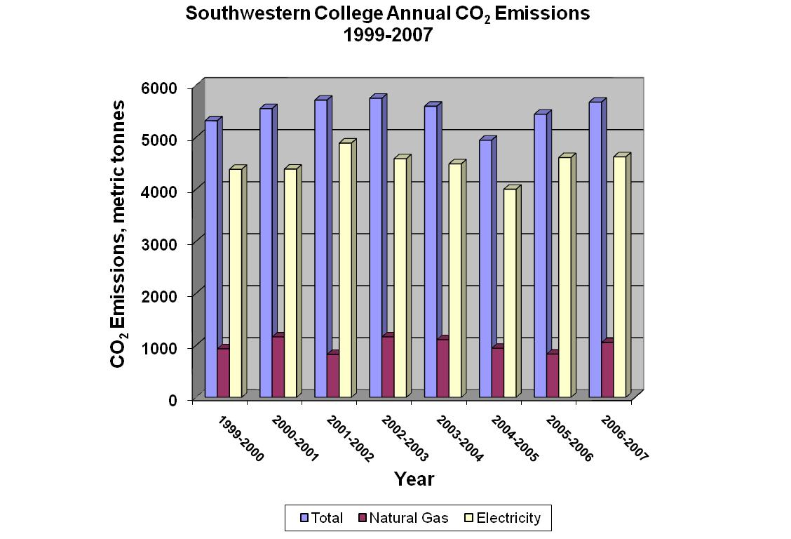
Under the guidance of Professor Cowlishaw, a team of Southwestern College students analyzed the main campus utility billings and calculated the consumption of natural gas and electricity for the years 1999-2007, beginning July 1 and ending June 30 for each year. The students then converted these values to metric tonnes of carbon dioxide emitted by the main campus each year. When plotted together (see figure above) there is a relatively small year-to-year variation in our campus footprint (mean, 5137 metric tonnes; standard deviation, <5%). Assuming that the demand for natural gas is highest in the cool months of the year and electricity demand is greater in the warmer months, much of this variation can be explained by inter-annual variation of temperature for the coldest and warmest months of the year.
We have established the year 2006-2007 as our base year for measuring our progress in emissions reduction with the implementation of our climate action plan. Currently, our measurement of campus emissions captures the contributions of the following emission categories:
  - Natural gas combustion and fleet fuel use (Scope 1)
  - Electricity use (Scope 2)
  - Air travel (Scope 3)
Our baseline carbon footprint totals 6,045 metric tons of CO₂. The pie chart below illustrates how each emission category contributes to the baseline footprint.
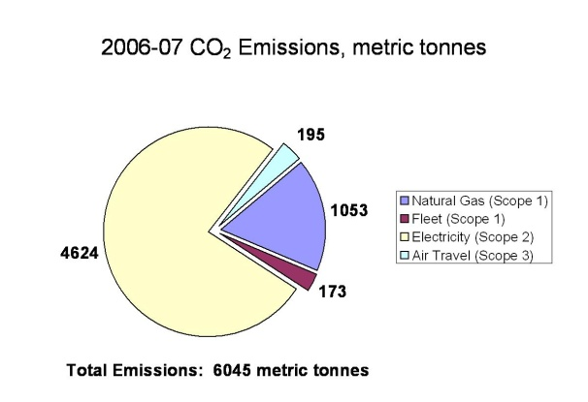
Greenhouse Gas (GHG) Inventory Update
An update of the GHG inventory for the year 2008-09 (July 1-June 30) reveals almost a 2% decrease from the 2006-07 baseline inventory total, and a 6% decrease in emissions attributed to natural gas and electricity use (see figure below). Increases in emissions related to air travel and fleet fuel negated much of that reduction. Questions have been raised regarding the accuracy of the tracking of air travel and fleet fuel purchasing from the 2006-2007 baseline total. Incomplete tracking of these emissions sources could lead to the perceived increase in fuel usage and air travel, when in reality, the baseline amount is may not be accurate. Tracking measures of both air travel and fleet use have been improved over the past two years and continue to be analyzed for further improvement.
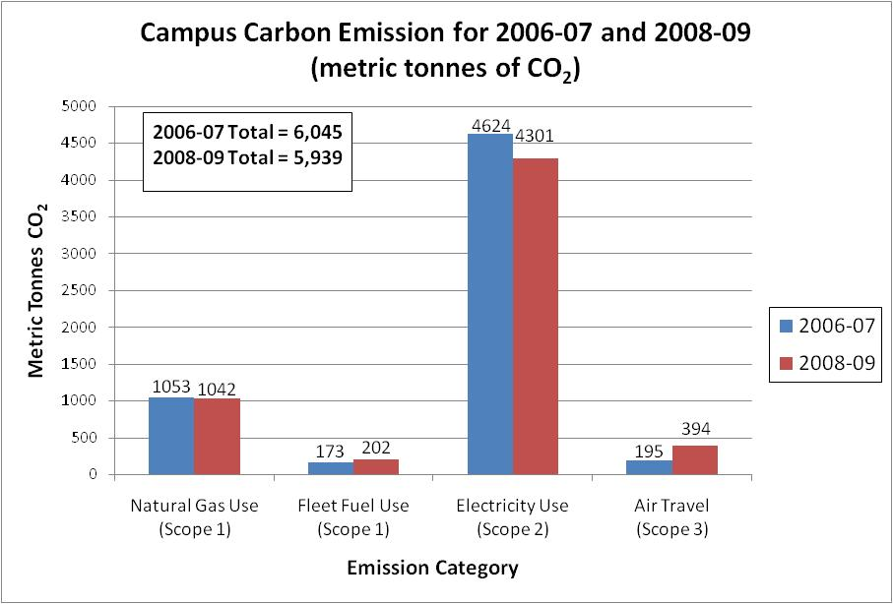
The percent reduction for emissions-related to electricity and natural gas use is greater than the seasonal variation observed in the 1999-2007 historical dataset. Thus, we can say with some certainty that the energy conservation upgrades and initiatives undertaken after the baseline year (explained in detail in the Mitigation section) by Sodexo, the college’s facilities and maintenance services contractor, after the baseline year have contributed to the overall reduction in the campus carbon footprint.
Mitigation
Our goal is to stop any increase in carbon emissions by 2010, and achieve a 20% reduction by 2015. Yearly reductions will be realized as a result of funding and the overall success of our plans. Our climate action plan will include the following mitigation components:
- conservation of energy,
- use of renewable energy sources,
- purchase of energy offsets.

Conservation
Equipment upgrades and other building renovations will be undertaken to improve the energy consumption of the college’s buildings.
During the summer of 2009, the college, in conjunction with Sodexo Facilities Services, undertook an energy and water conservation audit. The audit team performed site interviews, inspections, billing data reviews, and utility program reviews to become familiar with the college’s buildings, energy issues, and potential opportunities. Following the audit, Sodexo developed vendor quotes for building improvements.
The three largest energy conservation opportunities identified, in order of priority, are: recommission the building automation system after making mechanical improvements to all buildings, install lighting retrofits, and install residence hall temperature controllers. The auditors identified a number of additional measures – which are low- or no-cost items – to be undertaken. The total projected cost of these measures is $787,801, with a projected payback of 3.9 years, though the largest cost item, the building automation system, will have a slightly longer payback of 4.8 years.
The audit projects that, when completed, these projects will reduce the college’s energy carbon footprint by 28.9%. Sodexo has proposed a funding plan that will allow the college to proceed immediately with recommended conservation measures. This plan is currently under review by the college’s Board of Trustees. If approved by the Board of Trustees, the college projects that these conservation measures will be fully implemented by December 31, 2011. If the college chooses to fund these measures out of its current operating budget, the timeline for completion of these conservation measures could extend three to five years beyond December 31, 2011.
Because of the potential variability of the timeline, the college feels it is sensible to state that its 10-year goal for reduction of its greenhouse gas emissions is a 28.9% reduction.
Completed Conservation Upgrades and Initiatives
The following is a summary of the conservation upgrades and retrofitting initiatives that Southwestern College has completed over the past three years.
- May 2006 – installed low flow shower heads across campus
- June 2006 – upgraded HVAC for residence hall rooms in the lower floors of Sutton Hall were upgraded to high efficiency heat pumps
- July 2006 - upgraded existing building automation
- August 2006 - selected campus-wide temperatures in order to eliminate variations
- October 2006 - upgraded HVAC for offices in Sutton Hall
- October 2006 - replaced diesel generator at the campus greenhouse with natural gas-fired unit
- November 2006 - began project to replace top floor HVACs in Sutton Hall
- December 2006 - added a timer to reduce “on” time in Mossman and Beech Science Building hall lights.
- December 2006 - ordered trees for growing at field station. Trees to be planted when grown.
- December 2006 - established set temperatures for campus, moving to unify all set points.
- January 2007 - delivered lighting upgrade proposal and began Christy Administration Building upgrade
- March 2007 - upgraded lights at White Physical Education building
- June 2007 - installed Low-E insulated windows in all of library, upgraded all lights.
- June 2007 - replaced older 60% boiler with new 90% boiler in the south side of Christy Administration Building
- June 2007 - replaced two old 60% boilers with two new 90% boilers in the Library
- June 2007 - began data delivery to Loyalton Group for utilities audit
- July 2007 - replaced shower faucets and shower heads at White Physical Education building for reduced usage
- August 2007 - implemented Sodexo sustainable operations system, including green cleaning initiative
- October 2007 - upgraded lighting at Sutton Hall from T12 to T8
- December 2007 - began HVAC upgrade at Wallingford Hall. Installed 72 energy star heat pumps and two common space heat pumps. Replaced old 60% boiler. Project completed in summer of 2008
- January 2008 - Received four golf carts from Sodexo to be used on campus to save fuel, reducing usage of full size trucks
- June 2008 - Upgraded insulation on five roofs being replaced for better efficiency
- September 2008 - began recycling of cafeteria cardboard, plastics and steel containers
- November 2008 - replaced half of the windows at White Physical Education building with better insulated, sealed units
- June 2009 - replaced old boiler in Shriwise Apartments with new 97% boiler for better efficiency
- June 2009 - began work to prepare an Energy Saving Project for the college
Behavioral changes by students, faculty and staff will be encouraged with a variety of programs and incentives.
In 2008, Southwestern College created a Green Team composed of students and led by a director. The director of the Green Team is a salaried employee of the college. Details regarding the Green Team and its activities including its plans to affect the behavior of the students, faculty and staff of the college are explained in more detail in the Co-Curricular programs section under the heading Education, Research, Community Outreach Efforts.
Educational programs assisting faculty and staff in support of sustainable related investments will be offered. The college is just beginning to give attention to this issue. We expect a variety of curricular and co-curricular efforts in the future.
Renewable Energy
Solar, wind, and other forms of renewable energy will be introduced to the college as funding permits.
The college recently dedicated the Norman E. Hege Education Center at its Moore Biological Field Station north of the college’s campus. Although the Hege Center is a modest structure, the college took the significant step of investing in a hybrid wind-solar power generation system so that the addition of this modest facility square footage would not increase the college’s emission footprint. The college also gained valuable experience working with vendors of these power systems.
The college has completed a preliminary study of the potential for generation of wind power on a “small wind” scale using turbines installed on the east edge of the Southwestern campus. The installation of these turbines is technically feasible, though the impact on the college’s energy carbon footprint would be rather modest. The college is currently seeking a private investment partner who might wish to capitalize on available investment tax or production tax credits by making a more substantial investment in wind or solar generation.
Purchasing of energy offsets
Where our efforts to meet our target reductions in GHG emissions falls short by way of conservation and renewable energy installations, energy offset purchases will be considered as needed, and as finances allow.
Educational, Research, Community Outreach Efforts
Curricular changes will be made to provide instruction on sustainability in the general education program as well as in some majors. A minor in sustainability will be pursued.
We currently offer two courses in our General Education curriculum: Science, Society and the Environment and Environmental Issues. Both of these courses provide students with a focus on the root causes of environmental problems, how our understanding of them provides opportunities to develop new ways of living that respect the limits of the Earth system, and how scientific knowledge of the natural world around us is essential to knowing how we can move away from a growth economy model and devise a more sustainable one for the future.
At present, Southwestern College offers an academic minor in Environmental Studies through the Department of Integrative Studies. Although sustainability is discussed and underlies the content of course work in this degree program, we aim to develop a new minor in Sustainability that moves this concept to the focal point of the curriculum. This could readily be achieved by the synthesis of existing courses in the Environmental Studies minor and General Education offerings, together with programming and service learning opportunities connected with the Green Team (see below).
Co-curricular programs such as the Green Team and integration of energy reduction activities into other student groups will be pursued.
While it is true that organizational changes made by an institution of higher education such as Southwestern College are important to the cause of creating a sustainable world, the most important impact that any institution of higher learning can have is the lasting impact that it has on its students. As a part of Southwestern College’s green initiative and climate action plan, many steps will be taken to educate students, faculty and staff in the areas and good practices of environmental sustainability with the hope that behavioral changes toward more sustainable living will be made by all who interact with our institution.
One of the first steps that Southwestern College has taken in response to committing to become a sustainable institution is to form a Green Team. The Green Team is a service learning program whose vision is to “change the culture of Southwestern College toward one of more responsible citizenship in the area of environmental sustainability.” The Green Team is a campus organization for students interested in learning about and implementing sustainability on the Southwestern College campus, in their personal lives, in the Winfield community, and beyond. The Green Team is led by the Green Team director, a salaried staff position in the institution.
The Green Team will largely be responsible for encouraging behavioral changes by students, faculty, staff, and by the Winfield and Kansas communities through a myriad of programs, projects, and incentives. Examples of past, ongoing and future initiatives are listed with a brief explanation in the following sections
- Campus Recycling and Recyclemania Competition
  - Southwestern has instituted a campus recycling system that involves the majority of the campus student groups. Each student group manages the recycling for a particular campus building (i.e. Tri-Beta is in charge of recycling in Beech), and once a week, students volunteer to go around campus and collect the recycling and take it to the campus recycling shed. The Green Team oversees the operation of the recycling program and keeps the shed organized.
  - Southwestern College competed in Recyclemania for the first time in 2009. More than 22,000 pounds of waste was recycled during the 10-week competition. Southwestern also competes in the Waste Minimization division of Recyclemania. Initiatives such as providing refillable water bottles for the students and encouraging students, faculty and staff to print less are examples of efforts to reduce the amount of waste generated by the college.
  - Tri-Beta and the Green Team organized an annual recycling competition between the residence halls in order to encourage recycling. Prizes are awarded for the three residence halls that recycle the most during the spring semester.
- Campus Composting – the Green Team began a project to compost organic waste created by students in the residential apartments along with the plant waste generated by maintaining the campus landscape. The composting project hopes to expand to include the cafeteria waste in the future.
- Hosting Kansas Envirothon Competition – Southwestern College began hosting the Kansas Envirothon competition in 2009. The Kansas Envirothon is a state-wide competition for high school students and is a sub-competition of the national Canon Envirothon. Seventy high school students from 14 high schools in Kansas competed in the 2009 Kansas Envirothon. The competition focuses on the students’ knowledge of wildlife, forestry, aquatics, soils and a current issue that changes each year.
- Proposal to Reduce Paper Use – On average, Southwestern College uses more than 5,000 sheets of paper each day. The Green Team is currently investigating methods of reducing this amount of paper, and will recommend these methods to the institution. Methods being investigated include duplexing software, student print limits, tablet notebooks for professors, incentives for professors to strive for “paperless” courses and educating students on how to change printing habits.
- Green Presentations for Dormitory Residents – The Green Team has begun giving presentations on green topics in the campus residence halls. Educating students in the classroom and where they live on campus is very important in the attempt to helping them understand the importance of living a sustainable lifestyle and how to do so.
- Environmental Leaders as Guest Speakers – Southwestern College has brought multiple speakers to campus over the past two years whose message focuses on the importance of sustainability. These speakers have given formal and informal lectures to the students. Speakers include Dr. Anthony Cortese of Second Nature; John Hofmeister, former president of Shell Oil Company; and Chris Ballard of Greensburg, Kansas.
- Biology Field Station – Southwestern College recently installed a 2.5 kilowatt solar array and a 200 watt wind turbine that provide all of the power for the Moore Biology Field Station. The biology field station is an outdoor laboratory in which students can study native Kansas ecosystems and wildlife. The field station sits on 240 acres of land approximately 10 miles north of the Southwestern campus. The solar array and wind turbine will provide sufficient energy to power the classroom activities which will take place at the field station. A composting toilet was also installed in the cabin at the field station in order to turn waste into natural compost.
- Introduction to Sustainability Class – The director of the Green Team has developed an informal course which is taught to the incoming Green Team students. The Introduction to Sustainability class teaches the students about population growth, carbon footprints, fossil fuels, climate change, LEED building, renewable energy, alternative transportation, and the importance of conservation and personal lifestyle choices.
Future Initiatives
- Dorm Energy Competitions – Green Team Southwestern is investigating a metering system for the campus residence halls and residential apartments. Currently, most of the residential buildings are not singly metered for electricity usage, thus it is difficult to determine the major energy consumers or evaluate the difference that energy efficient improvements actually make. The Green Team would like to install individual meters in each of the eight residence halls and apartment complexes on campus in order to determine which residence halls consume the most energy per capita and attempt to conserve energy and improve students’ energy habits through dorm energy competitions.
- Green Camp for High School Students – The Green Team is organizing the first annual Green Team Green Camp for high school students. The camp will take place in July 2010 and we hope to have 30-50 students participate. During the camp, the participants will explore water quality and testing, renewable energy, LEED building, locally grown foods, recycling and the importance of their personal decisions. Participants will also tour a nearby wind farm, recycling center, and Greensburg, Kansas. The camp will be a mixture of learning, application, competition and fun.
- Creation Care Day for High School Youth Groups – The Green Team is also in the process of planning a Creation Care Day for area church youth groups. Creation Care Day will teach students Biblical principles on environmental sustainability and how they can live more sustainably at home, school and church. The high school students will interact with professors and students from Southwestern College and be challenged to implement changes in their personal lifestyle.
- Cafeteria Tray Elimination – In 2008, the Green Team performed an investigation into the environmental impact of the plastic tray use in the campus cafeteria. The results of the analysis determined that the college could conserve approximately 6,000 pounds of food waste and nearly 20,000 gallons of water by simply removing the trays and forcing students to carry their plates and cups separately. The Green Team is currently working with Sodexo and cafeteria management to determine the changes that need to take place in order to eliminate the trays.
Financing
The college plans to finance its sustainability programs through a combination of means: direct allocation of institutional funds through the annual budgeting process, performance contracting (or some variant of the performance contracting model) in which improvements are funded by an external source that is repaid through reduced energy usage and related costs, solicitation of gifts and grants, and, potentially, through bonding for capital projects through the Kansas Independent College Finance Authority. At present, all financing means except bonding are being used or are actively contemplated.
Conclusion
Southwestern College is excited to be elevating, as an institutional priority, our efforts to live by and teach a sustainable way of life. We believe we are off to a good start, with many opportunities ahead. In this process we have discovered new challenges in both our ability to monitor and reduce our energy use. We anticipate a college-wide effort in this area which will influence our institution, community and the lives of all who study and interact with Southwestern College in the years ahead.

